
PARENTAL CONSENT FORM - SHOOTING ACTIVITIES
PLEASE NOTE: SPECIFIC PARENTAL PERMISSION IS NEEDED BEFORE A YOUNG PERSON CAN TAKE PART IN THIS ACTIVITY.
Upper section to be completed by the Leader in charge of the activity.
Lower section to be completed by the Parent or Guardian and returned to the Leader.
Name of section: - Scouts, Explorers and Network
Proposed activity: - Air Rifle Target Shooting for the Intercounty Shooting Competition 2019
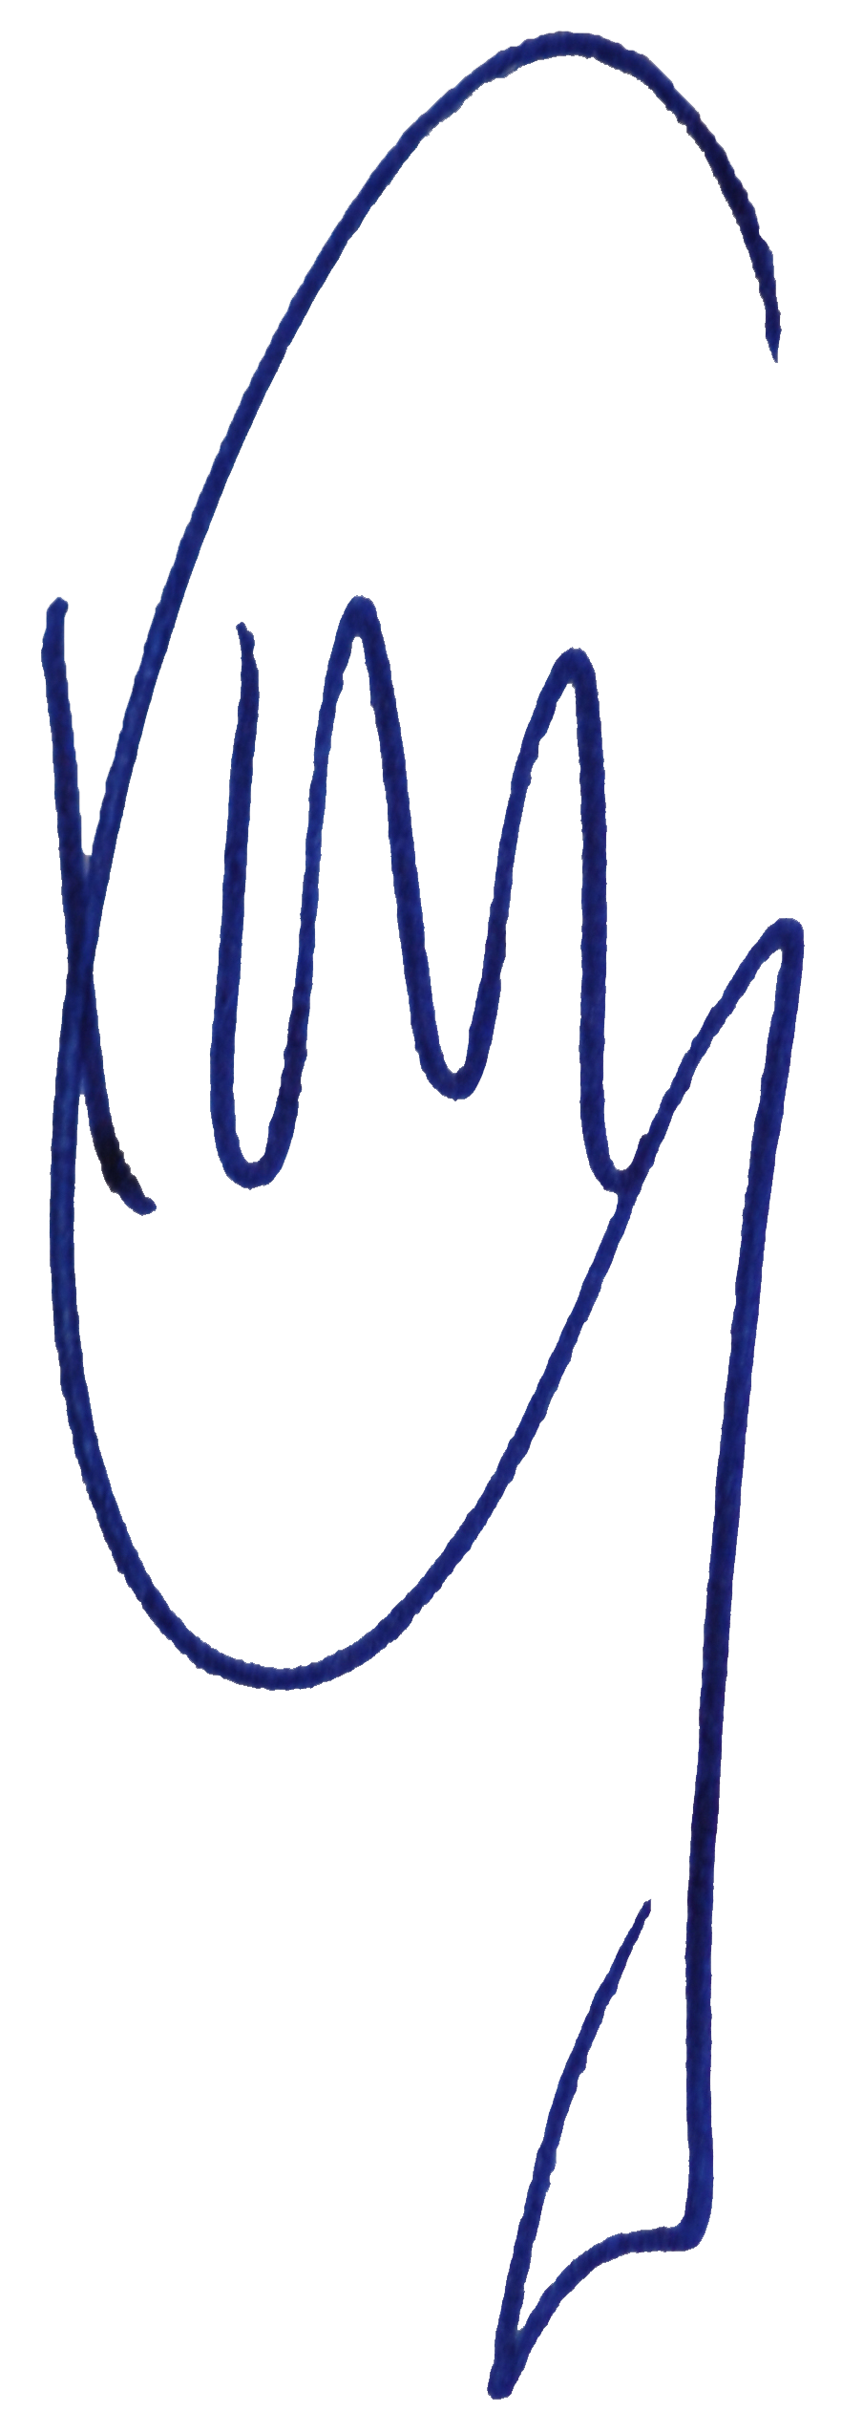
Dates: Sundays between Sept 2018 and May 2019 Start time 1900 Finish time 2030
Cost: - £1 (to be paid each evening of attendance)
Cheques payable to: N/A
Additional information. Scouts will be instructed and taught the safe use of guns and techniques to prepare them for the competition.
All Leaders will be qualified to the Scout Association's rules for shooting, if in doubt please ask.
Leader: Ian Guy Signature: Date: 09/01/2019
Phone No: 07525 328 277
If any additional information is required, please do not hesitate to contact the Leader of the activity.  ----------------------------------------------------------------------------------------

Parent's or Guardian's consent
(Before signing please read attached extracts printed on the reverse of the form) I being the parent/guardian of the person named below declare that he/she is not subject to restriction by virtue of the regulations set out in Section 21 of the Firearms Act 1968 (extract printed overleaf) and hereby give permission for
I have noted the arrangements and give my permission for_________________________(name of young person) to take part in target shooting on and for the Leader to sign any medical forms in event of any accident if quick contact cannot be made.
Please state if your Son or Daughter has a disability or condition, which might affect the activity:
Please indicate details of any medical treatment he/she is receiving at the moment: -__________
Contact details________________________________________________________________
Name: -_____________________ Signature: -__________________ Date: -______________
Extracts from the Firearms Act 1968
‘Section 21’
(1) A person who has been sentenced (to custody for life or) to preventive detention, or to imprisonment or to corrective training for a term of three years or more (or to youth custody (or detention in a young offender institution) for such a term), or who has been sentenced to be detained for such a term in a young offenders institution in Scotland, shall not at any time have a firearm or ammunition in his possession
.
(2) A person who has been sentenced to imprisonment for a term of three months or more but less than three years ( or to youth custody ( or detention in a young offender institution) for such a term), or who has been sentenced to be detained for such a term in a detention centre or in a young offenders institution In Scotland, shall not at any time before the expiration of the period of five years from the date of his release have a firearm or ammunition in his possession.

This means:
Section 21 prohibits the possession of a firearm and ammunition (under any circumstances), by any person who has been convicted of a crime and sentenced to a term of imprisonment (or its equivalent for young persons) of 3 months or more. The prohibition applies in all circumstances, including handling and firing at an approved shooting club or at a clay pigeon shoot where a certificate is not ordinarily required. It also applies to the possession or use of other categories of firearms and ammunition such as AIRGUNS or shot cartridges for which a certificate is not needed.
A sentence of 3 months to 3 years attracts a 5-year prohibition, shorter ones no prohibition but a longer one means a life ban.

